**August 24, 2025 11th Sunday after Pentecost**

**Welcome! We are glad you came to worship with us today!**

**It is our prayer that you will be richly blessed as we worship**.

**†Denotes please stand as you are able in praise to God.**

**Pastoral Greeting:**

**Call to Worship:**

L: The Lord is our rock and our refuge.

**P: God is our fortress in times of trouble.**

L: The Holy One saves us from the hand of the wicked.

**P: God delivers us from our foes.**

L: Christ heals us from our infirmities.

**P: The Spirit frees us from the chains that bind us.**

L: Rest in the Source of our refuge and our strength.

**†Opening Hymn:**

**“I Was There to Hear Your Borning Cry” TFWS #2051**

**Call to Prayer of Confession:**

L: Trusting in the promises given at our baptism, let us confess our sin before God and one another.

**All: Eternal God, you knew us before we were conceived.  
You called us as your own while we were still in our mothers’ wombs. Keep watch over us, we pray, for we long to return to your ways. Restore our confidence in times of doubt, for we yearn to be the people you would have us be. Grant us the confidence to go forth unafraid, that we might bless the world through your presence in our lives. Amen.**

**Words of Assurance:**

**†Affirmation of Faith: “The Apostles Creed” UMH #881**

**†Gloria Patri: UMH #70**

**Passing the Peace of Christ:**

**Prayer for Illumination:**

**All: Lord, open our hearts and minds by the power of your Holy Spirit, that, as the Scriptures are read and your Word proclaimed, we may hear with joy what you say to us today. Amen.**

**O.T. Scripture: Jeremiah 1:4-10 Pew Bible Pg. 533**

**N.T. Scripture: Hebrews 12:18-29 Pew Bible Pg. 853**

**†Gospel Scripture: Luke 13:10-17 Pew Bible Pg. 737**

**Hymn of Preparation:**

**“There's Something About That Name” UMH #171**

**Message:**

**“Living Faith Is Our Refuge and Freedom”** **Rev. Carolyn Heisler**

**Special Music:**

**Pastoral and Lord’s Prayer: (see bulletin insert)**

**Offering of Our Tithes and Gifts:**

**\*The Doxology: “Praise God……. UMH #95**

**†Closing Hymn: “Here I Am Lord” UMH #593**

**Benediction and Sending Forth:**

L: God has set us free.

**P: God releases us from bondage.**

L: Christ has made us whole.

**P: Christ heals our wounds.**

L: The Spirit has strengthened us for the journey.

**P: God’s Spirit sends us forth.**

L: Go with the confidence of God’s anointed and His open uncompromised refuge. Go in peace and joy with love in your heart.

**Sending Forth: “Make Me A Servant” TFWS #2176**

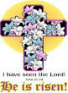

***Church Annoucements!!!!***

***Weekly Church Services:***

***Sunday School: 9:00 a.m.***

***Sunday Morning Worship: 10:00 a.m.***

***Weekly Bible Study: Wednesdays at 7:00 p.m.***

***Church Staff:***

**Ministers: All Members of the Congregation**

**Asst. to the Ministers: Jay W. Brown, CLM, OSL-Pastor**

**(609)238-6916(C)**

**Lay Leader & Secretary: Lettie-Jane White (856) 768-3416**

**Administrative Chairperson: Jack L. Turner, Jr.**

**Administrative Chairperson: (Emeritus) Roberta Suloff**

**Trustees Chairperson: Robert White**

**Please invite family and friends to view or follow our Sunday Worship at 10:00 a.m. on Zoom.**

**This is the Zoom Meeting ID and Password:**

**Meeting ID: 84694237019  
Passcode: church**

**You can also join the Zoom Meeting using the below:**

**Wesley United Methodist Church**

**159 Bate Ave. West Berlin, NJ 08091**

**Church phone - -856-767-9269**

**Email:** [**wesleyumc2020@gmail.com**](mailto:wesleyumc2020@gmail.com)

**Website:** **wesleyumcwestberlin.org**

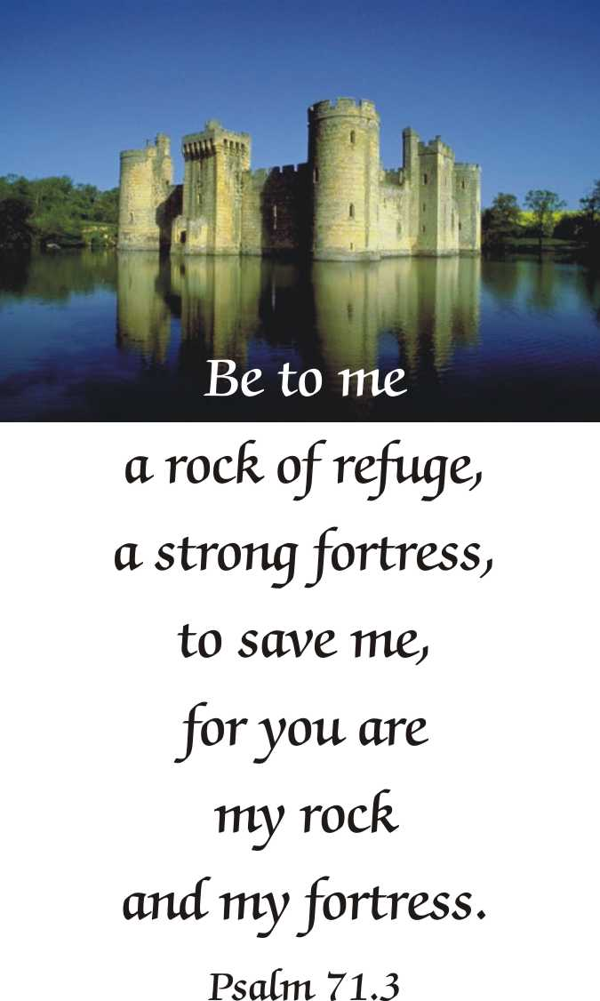

***“The United Methodist Church forms disciples of Jesus Christ who, empowered by the Holy Spirit, love boldly, serve joyfully, and lead courageously in local communities and worldwide connections.”***

**HERE I AM, LORD**

**I, the Lord of sea and sky,  
I have heard My people cry.  
All who dwell in dark and sin,  
My hand will save.  
  
I who made the stars of night,  
I will make their darkness bright.  
Who will bear My light to them?  
Whom shall I send?  
  
Here I am Lord, Is it I Lord?  
I have heard You calling in the night.  
I will go Lord, if You lead me.  
I will hold Your people in my heart.  
  
I, the Lord of snow and rain,  
I have born my peoples pain.  
I have wept for love of them, They turn away.  
I will break their hearts of stone,  
Give them hearts for love alone.  
I will speak My word to them,  
Whom shall I send?  
  
Here I am Lord, Is it I Lord?  
I have heard You calling in the night.  
I will go Lord, if You lead me.  
I will hold Your people in my heart.  
  
I, the Lord of wind and flame,  
I will tend the poor and lame.  
I will set a feast for them,  
My hand will save  
Finest bread I will provide,  
Till their hearts be satisfied.  
I will give My life to them,  
Whom shall I send?  
  
Here I am Lord, Is it I Lord?  
I have heard You calling in the night.  
I will go Lord, if You lead me.  
I will hold Your people in my heart.**

**HERE I AM, LORD**

**I, the Lord of sea and sky,  
I have heard My people cry.  
All who dwell in dark and sin,  
My hand will save.  
  
I who made the stars of night,  
I will make their darkness bright.  
Who will bear My light to them?  
Whom shall I send?  
  
Here I am Lord, Is it I Lord?  
I have heard You calling in the night.  
I will go Lord, if You lead me.  
I will hold Your people in my heart.  
  
I, the Lord of snow and rain,  
I have born my peoples pain.  
I have wept for love of them, They turn away.  
I will break their hearts of stone,  
Give them hearts for love alone.  
I will speak My word to them,  
Whom shall I send?  
  
Here I am Lord, Is it I Lord?  
I have heard You calling in the night.  
I will go Lord, if You lead me.  
I will hold Your people in my heart.  
  
I, the Lord of wind and flame,  
I will tend the poor and lame.  
I will set a feast for them,  
My hand will save  
Finest bread I will provide,  
Till their hearts be satisfied.  
I will give My life to them,  
Whom shall I send?  
  
Here I am Lord, Is it I Lord?  
I have heard You calling in the night.  
I will go Lord, if You lead me.  
I will hold Your people in my heart.**